**Assignment Number 1 –** BASICS OF EXCEL

Register Number: 1740256

**Date:** 12/06/2017

**Note**: All assignments will have the following –

1. **Aim** – This is the question given for working out.
2. **Procedure** – These are the steps which are required to work out a given problem.
3. **Calculations** – Which is the screenshot of the working of the problem.
4. **Conclusions** – Which is to be drawn from the calculations.

--------------------------------------------------------------------------------------------------------------------------------

1. **Aim** - Form a data set of 25 observations with the following contents:

**Procedure** –

1. Open a new MS Worksheet using a column heading as specified.
2. Fill in the 25 steps of observation in the worksheet.
3. Go to insert option, click on table and press ok on the dialogue box. This converts the entire data in the table.
4. Save the file using the option - save as, and by giving a name to the file.

**Calculations –**

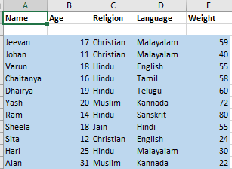

**Conclusion** – The calculations has a list of a few of the 25 names with their respective ages, languages, weight and religion.

---------------------------------------------------------------------------------------------------------------------------------

1. **Aim** – To sort the given data for people in alphabetical order according to the person’s name.

**Procedure** -

1. Select the name column.
2. Click on the arrow at the top of the column and a drop down menu appears.
3. Click on the way you want it to be sorted and we see the expected result.

**Calculations –**

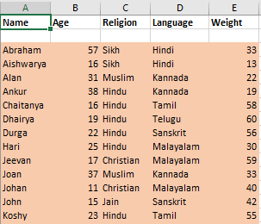

**Conclusion –** Compared to the previous question, this data has been sorted according to their names in alphabetical order with respect to their Age, Religion, Language & weight .

---------------------------------------------------------------------------------------------------------------------------------

1. **Aim** – To sort the given data for people in accordance with their language.

**Procedure** -

1. Select the language column.
2. Click on the arrow at the top of the column and a drop down menu appears.
3. Click on the way you want it to be sorted and we see the expected result.

**Calculations –**

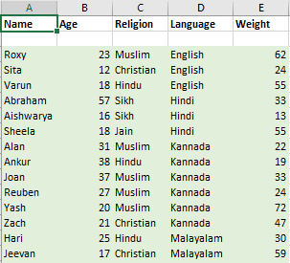

**Conclusion –** These calculations are based on sorting people together based on their respective languages.

---------------------------------------------------------------------------------------------------------------------------------

1. **Aim** – To sort the given data for people in accordance with their ages from smallest to largest.

**Procedure** -

1. Select the age column.
2. Click on the arrow at the top of the column and a drop down menu appears.
3. Click on the way you want it to be sorted and we see the expected result.

**Calculations** –

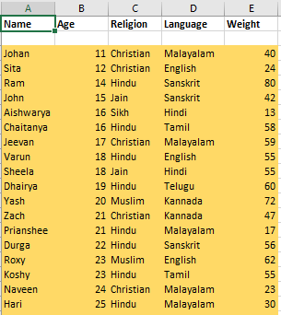

**Conclusion –** These calculations are based on sorting people together based on their respective ages from smallest to largest.

---------------------------------------------------------------------------------------------------------------------------------

THE END

--------------------------------------------------------------------------------------------